Brainstorm & Idea Prioritization Template

Parameter | Details
Date | 18 June 2026
Team ID
Project Name | Book A Doctor
Maximum Marks | 4 Marks

____________________________________________________

Brainstorm & Idea Prioritization Template:
Brainstorming provides a free and open environment that encourages everyone within a team to participate in the creative thinking process that leads to problem solving. Prioritizing volume over value, out-of-the-box ideas are welcome and built upon, and all participants are encouraged to collaborate, helping each other develop a rich amount of creative solutions.
Use this template in your own brainstorming sessions so your team can unleash their imagination and start shaping concepts even if you're not sitting in the same room.

Step-1: Team Gathering, Collaboration and Select the Problem Statement
The team gathered to identify core scheduling and coordination issues in local medical clinics. The selected problem statement focuses on creating a real-time booking and document management platform to connect patients, doctors, and system administrators.

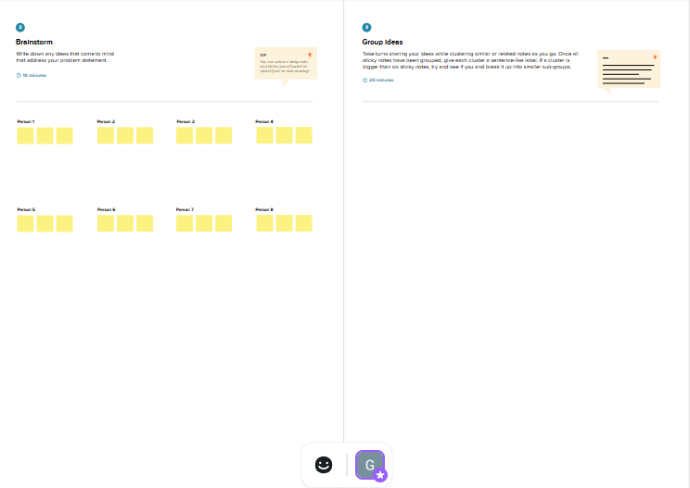
Brainstorming Step 1

Step-2: Brainstorm, Idea Listing and Grouping
Ideas were grouped into key clusters: Auth/Identity, Scheduling engines, File uploads repositories, and Admin verify panels.

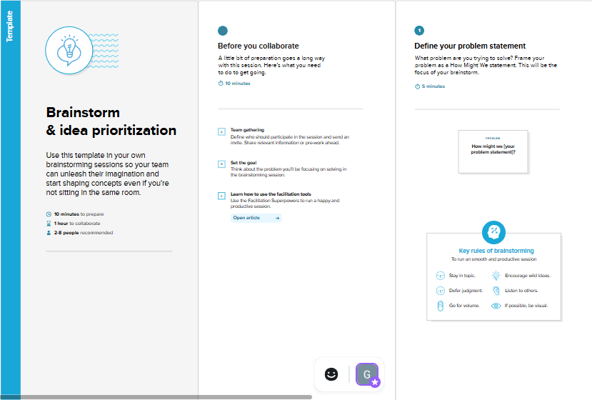
Brainstorming Step 2

Step-3: Idea Prioritization
We prioritized features by Impact and Effort using a quadrants matrix:

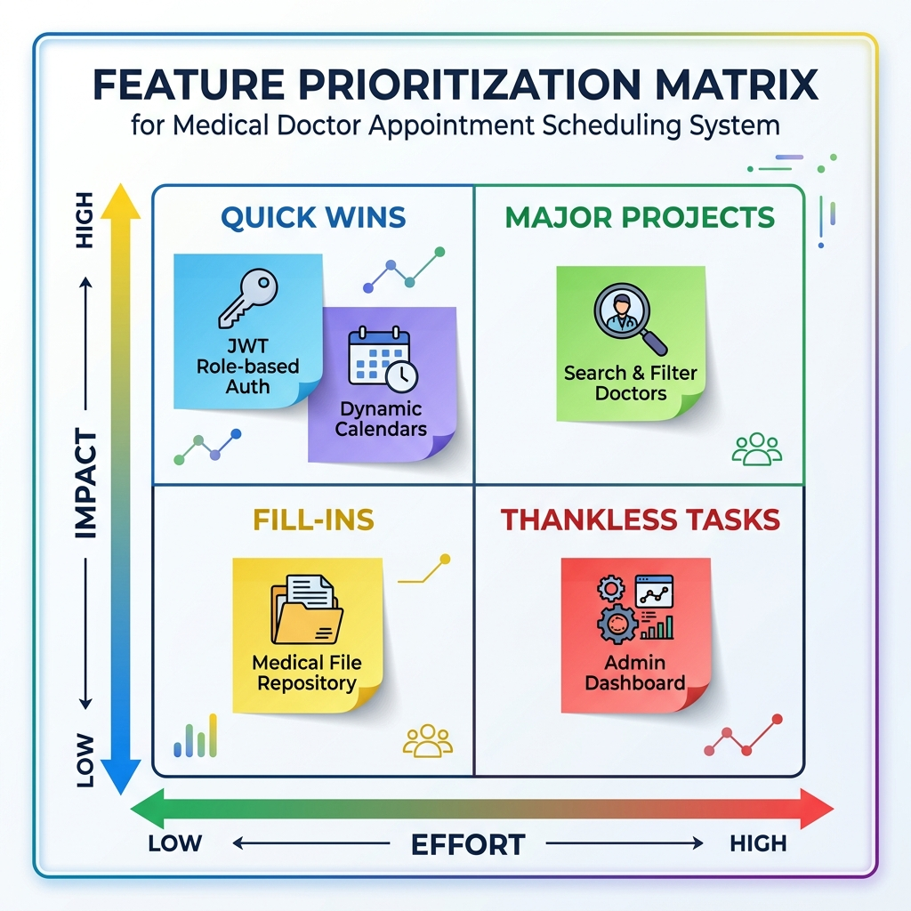
Prioritization Matrix

